**1.INTRODUCTION**

# 1.1 Overview

In this project, we will build a process to Grade Calculation Excel Automation that works over Microsoft Excel 2013 using Blue prism.

# 1.2 Purpose

Generally,in order to calculate grades we use manual formulas in Excel.We also need to enter the marks manually each time. Our goal through this project is to automate this whole process with the help of RPA technology and Blueprism. We can avoid doing the rote and recurring task of calculating grade for each student based on their marks repeatedly and save time with the help of this project.

# 2.LITERATURE SURVEY

## 2.1 Existing Problem

At present,in order to calculate grades we have to use Excel

Formulas.This makes the task repetetive and rote.We need to manually type the formulas for each student while calculating their grade.

## 2.2 Proposed Solution

In order to overcome the problem mentioned above,we will use RPA technology to automate the process of grade calculation.With the help of Digital Workers in Blueprism software our whole process of calculating the grades will be automated.It will save us a lot of time and make this task very efficient.

# 3.THEORITICAL ANALYSIS

## 3.1 Block Diagram 3.2 Hardware / Software Designing

i.Windows 10 OS ii.Blueprism Software iii.Microsoft Excel iv.250 GB hard drive

v.Ram 8 GB

# 4.EXPERIMENTAL INVESTIGATIONS

## Object-based approach

Object-based is the standard approach to automating all desktop applications. In this case, the bot emulates the actions of a real person, typing and clicking on buttons and other elements on the UI. It allows you to automate all actions in Excel that a real person can do, if they are routine and rule-based. However, when the bot interacts with the application UI rather than with the file directly,

as when API is used the speed of execution is slower than with the two approaches above, and the application needs to be opened on the screen.

There are several approaches to automating Excel with RPA:

* Coding using RPA API and other API tools
* Native actions for Excel automation
* Object-based automation

# 5.FLOWCHART

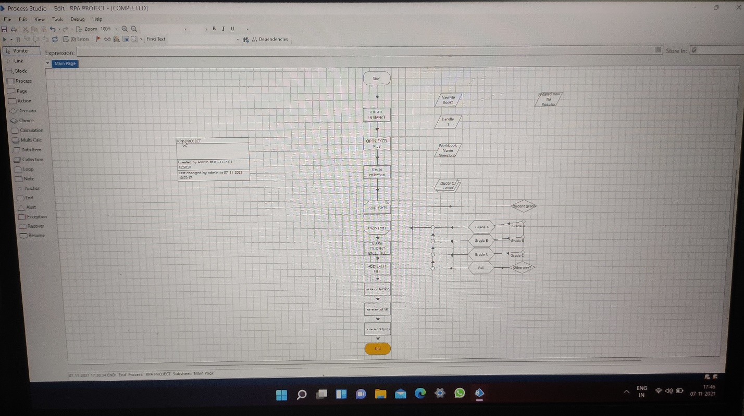

# 6.RESULT

All the flows was executed successfully by reading the given excel sheet and the output was stored new excel document as output.

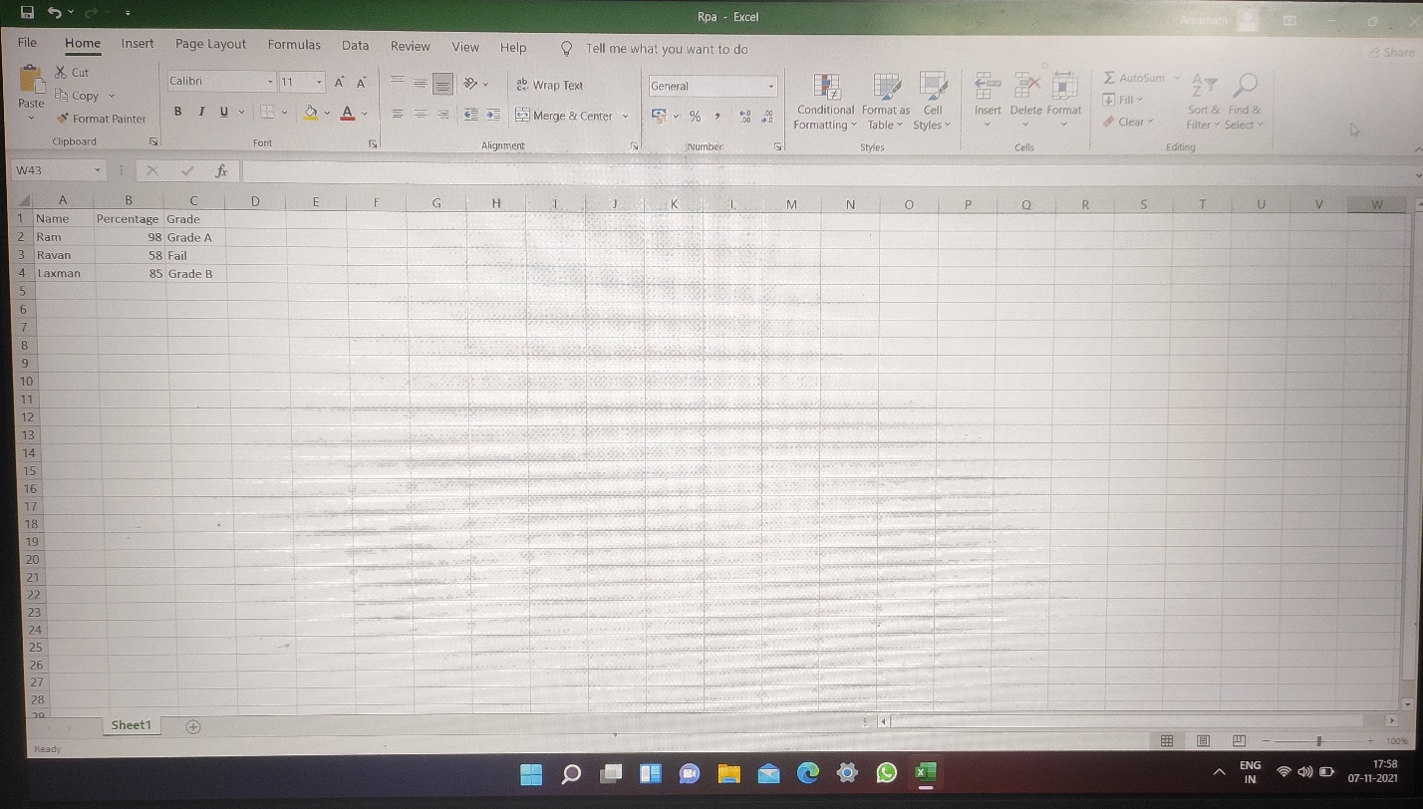

# 7.ADVANTAGES AND DISADVANTAGES

**Advantages:**

i.More efficient.

ii.Improved accuracy by eliminating human error.

iii.Increased agility as it makes easier for us to adapt if any changes are to be made. **Disadvantages:**

i.Added complexity as when RPA is not managed and documented properly,it can make the task in hand more complex.

ii.Managing and maintaining of bots can be a tough job if not done with expertise.

# 8.APPLICATIONS

This solution can be applied in schools or colleges which have a rich IT infrastructure so that people can be more efficient and use their saved time in other areas of work.

It can also be applied by private tutors so that the menial job of repetitive calculation of grades for each student can be avoided as the whole process gets automated.

**9.CONCLUSION**

Excel is a very flexible instrument to perform analyses and what-if scenario’s. You use formulas in cells with one or more input cells to calculate the various situations. To ease working with different values and/or choices, you can put the controls from either the Control toolbox or the Forms toolbar to good use. Proper use of these controls make your models easier to use